Advanced Placement Exams: May 5th- May 16th 2025

Registration Due: November 8, 2025

Payment due Spring 2025

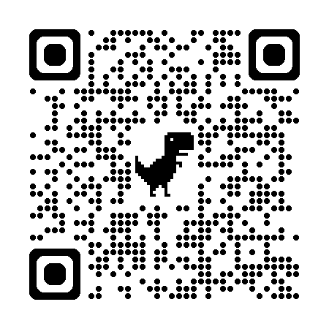Exam Dates MyAp

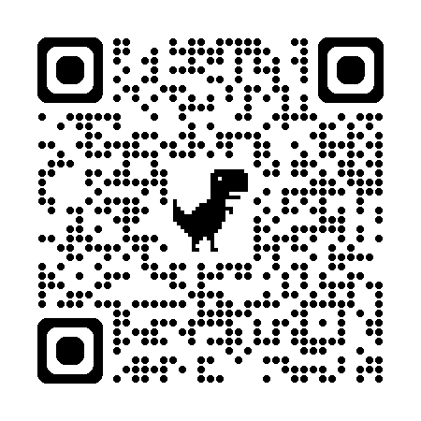

* Complete the process by visiting [**MyAP.CollegeBoard.org**](https://myap.collegeboard.org/) or QR code above and log in to your College Board account.
* Create a new account if you do not already have one.  Once logged in, go to the AP Classroom page.
* Enroll all your AP courses and exams in the College Board's “MyAP" system with the Join Codes you received from your teacher.
* You need to check MyAP to confirm that all classes are listed.
* **For EACH class, you must indicate whether you plan to test by responding "YES" or "NO" in the "ORDER EXAM" section**.  **“UNDECIDED” will be taken as “NO”.**
* Be sure to complete this task for each class and its exam. Winslow will only order exams for students appropriately joined in MyAP.
* This year, each AP exam costs $90.00. Students with Free/Reduced lunch will owe a discounted rate (to be determined at a later date).
* Late testing for those going on the Senior Trip to **Disney only**:
  + May 8th- Statistics (late exam May 21st) and AP World (late exam May 19th)
  + May 12th: Calculus AB/BC (Late exam 5/22)

|  |  |  |
| --- | --- | --- |
| Week 1 | Morning exam  7:30am | Afternoon exam 11:30am |
| Monday May 5, 2025 | Biology |  |
| Tuesday May 6, 2025 | Chemistry | US Government |
| Wednesday May 7, 2025 | English Literature Pino | Computer Science A |
| Thursday May 8, 2025 | Statistics | World History |
| Friday May 9, 2025 | US History |  |

|  |  |  |
| --- | --- | --- |
| Week 2 | Morning exam 8am | Afternoon exam 12pm |
| Monday May 12, 2025 | Calculus AB/BC |  |
| Tuesday May 13, 2025 |  | Environmental  Physics II |
| Wednesday May 14, 2025 | English Language-Bracy |  |
| Thursday May 15, 2025 | Spanish Language |  |
| Friday May 16, 2025 | Physics I | Psychology |

**\*\*Students taking afternoon exams will need their own transportation home. There are no buses. Testing concludes 3:15-3:30pm.\*\***